Activity 3: Industry Standard Programming Tools

1. Flow chart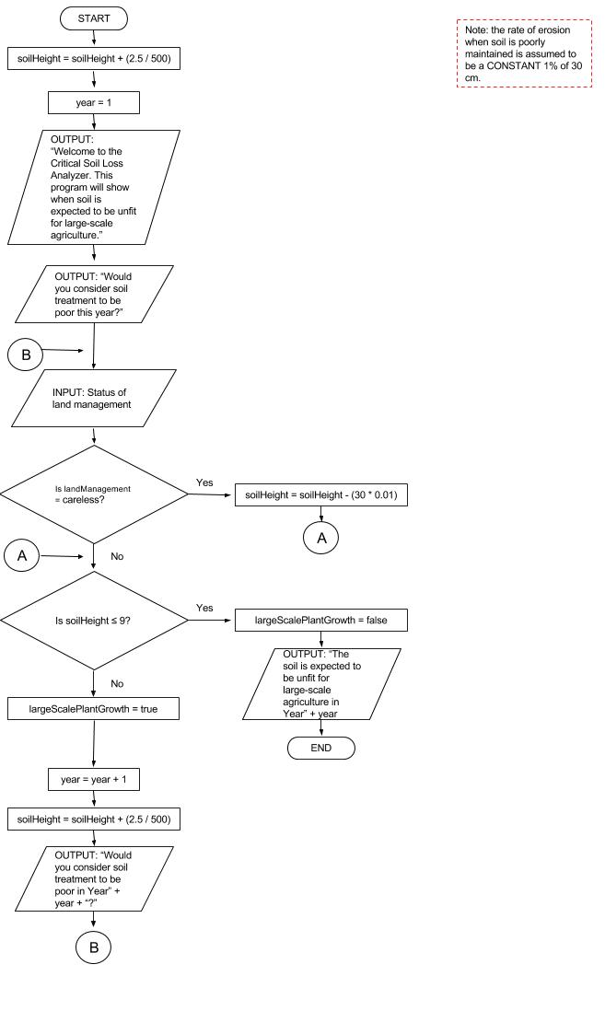
2. Hierarchical chart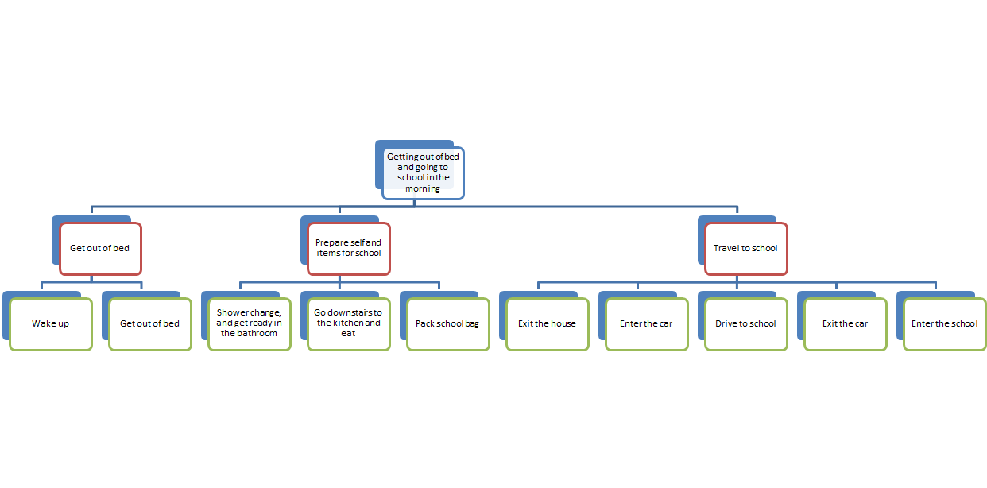
3. Pseudocode
4. Print LIST THREE VALUES FOR THE SIDES OF A TRIANGLE; SIDE LENGTH C MUST BE THE LONGEST OF THE THREE VALUES
5. Get side length A from user.
6. Get side length B from user.
7. Get side length C from user.
8. Multiply side length A by itself, producing side length AA.
9. Multiply side length B by itself, producing side length BB.
10. Multiple side length C by itself, producing side length CC.
11. Add side length AA and side length BB, producing side length AB
12. If side length AB is equal to side length CC, print THIS IS A RIGHT TRIANGLE. If side length AB is not equal to side length CC, print THIS IS NOT A RIGHT TRIANGLE